Kotara Bowling and Recreation Club Co Operative Limited.
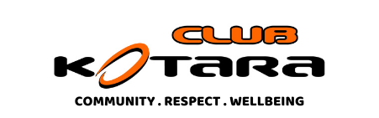
DIRECTOR NOMINATIONS are now open for the following 2 board positions.
NOMINATION FORMS are available at the Bar.
President (3 year term)
Director (3 year term)
Nominations close 5pm Friday 14 November 2025

QUALIFICATIONS OF DIRECTORS (Club Rules - Clause 45)
A person shall not be elected as director of the co-operative unless the person is an active member of the co-operative and is eligible under Rule 18. Bowling, Pensioner, Senior, Gala and Life Members may be elected to any position on the board. Social members may be elected as ordinary Board members only. There shall not be more than three (3) Social members on the Board at any one time. A member who is an employee of the co-operative is not eligible to hold office as a director.

The AGM will be held 10.00am at the Club on Sunday November 30, 2025.

Kotara Bowling and Recreation Club Co Operative Limited.
NOMINATIONS are now open for the following Club positions.
NOMINATION FORMS are available at the Bar.
Patron (1 Year)
Returning Officer (1 year term)
Deputy Returning Officer (1 year term)
Publicity Officer (1 year term)
Greens Liaison Officer (1 year term)
NDBA Delegate (2) (1 year term)
Selectors (see note below) (1 year term)
Games Organiser (1 year term)
Nominations close 5pm Friday November 14, 2025
Note: In accordance with Clause 37.(a)(xii) of the Club Rules the number of selectors is determined in the AGM.
The AGM will be held 10.00am at the Club on Sunday NOVEMBER 30, 2025.

